MOTION CONTROLLED COMPUTER USING ARDUINO

 Yar Zar Min , UG Student  
 *Department of CSE*  
 *Rajalakshmi Engineering College*Chennai, India  
*210701318*@rajalakshmi.edu.in

 Yaashish G , UG Student  
 *Department of CSE*  
 *Rajalakshmi Engineering College*Chennai, India  
*210701317*@rajalakshmi.edu.in

 Shiyaam Prasad V, UG Student *Department of CSE*  
*Rajalakshmi Engineering College*Chennai, India  
*210701321*@rajalakshmi.edu.in

***ABSTRACT -*In recent days, the automation in the domain of robotics has motivated researchers to develop more flexible and user-friendly machines. This innovation aims to create systems that are not only sophisticated in function but also simple in operation, making them accessible to a broader audience. One significant application of this technology is in controlling computer or laptop desktop functionalities through various human hand gestures.In this system, a Human Machine Interface (HMI) plays a pivotal role in facilitating seamless data exchange between computers and humans. The current design integrates an HMI system capable of controlling system applications such as volume adjustment, vertical and horizontal scrolling, tab shifting, and other desktop operations, all without the need for traditional input devices like a mouse, keyboard, or joystick.This technology holds great promise for individuals with physical disabilities, particularly those who are paralyzed, as it enables them to interact with computers without relying on conventional electronic gadgets. By using simple, unique hand gestures, users can command the system, thereby significantly reducing the gap between the user and the machine.The core of the present system utilizes a basic Arduino Uno microcontroller to support the motion-controlled interface. This setup involves sensors and motion detection algorithms that interpret hand movements and translate them into specific computer commands. The Arduino Uno, known for its simplicity and versatility, serves as an ideal platform for prototyping and implementing this**

**gesture-based control system.This approach not only enhances accessibility for users with physical limitations but also introduces a new dimension of**

**convenience and efficiency in human-computer interaction. The implementation of such a system could revolutionize the way we interact with our devices, making technology more inclusive and user-centric.**

***Keywords - Human Machine Interface (HMI)***

I. INTRODUCTION

As technology continues to evolve, making human life easier and safer, our main aim is to reduce the effort of interaction with computers or laptops through input devices by using simple gestures. Gesture-based interactions are becoming increasingly popular both in the workplace and in everyday life. While you might be familiar with robots being controlled by hand gestures, our project applies a similar concept to personal computers. This work aims to develop a system that can recognize hand gestures, which can then be used as input commands for interacting with a PC or laptop.One of the key areas that require careful attention during the development of such systems is the code implementation stage. For this project, we will be using Python to implement the code, leveraging its robust libraries for sensor data processing, machine learning, and computer vision.Our methodology involves several steps, starting with the hardware setup. This involves connecting an ultrasonic sensor to an Arduino board to measure the distance and movement of hand gestures. The Arduino is programmed to interpret hand gestures based on sensor data, with fine-tuned distance thresholds and filtering techniques to enhance accuracy. These techniques help distinguish between intentional gestures and incidental movements, providing a reliable input method for the system.Simultaneously, a Python environment is established on the computer to facilitate communication with the Arduino via USB. This setup includes installing necessary libraries and configuring the environment to process incoming data from the Arduino. The Python script handles data interpretation and executes gesture recognition using machine learning algorithms such as k-Nearest Neighbors (KNN). A crucial part of the methodology is the training phase, where a comprehensive dataset of known hand gestures is collected to train the KNN algorithm. This dataset includes a variety of gestures performed under different conditions to ensure the model can accurately classify new gestures.The system's core lies in the precise gesture recognition facilitated by the integration of sensor data analysis and machine learning. The Arduino transmits the sensor data to the computer, where Python processes it. The classified gestures are then mapped to specific computer functions, such as adjusting volume, scrolling, or switching tabs, enabling a seamless user experience.We believe that successfully meeting our goals will contribute to the future of natural gesture-based interfaces, even if only in a minimal way. Beyond accessibility for individuals with physical disabilities, gesture-based controls offer a more intuitive and immersive way to interact with computers, which can be particularly useful in environments where traditional input devices are impractical. Additionally, this technology has potential applications in various fields, including gaming, virtual reality, and smart home automation, providing users with more intuitive control mechanisms.Our project showcases the potential of gesture-based interfaces to transform how we interact with technology, making it more inclusive and user-friendly. By enabling users to control their computers with simple hand gestures, this technology not only enhances accessibility but also introduces a natural way to interact with machines. We look forward to sharing a detailed look into the project's working analysis and the results we achieved, demonstrating the significant advancements in human-computer interaction.

1. MATERIALS AND METHODS

The project begins with setting up the hardware components. The Arduino Uno is connected to the motion sensors and the camera module. The motion sensors are mounted on a glove or a hand-held device to capture the user's hand movements. The camera is positioned to have a clear view of the gestures performed by the user.Next, the software implementation starts with programming the Arduino Uno using the Arduino IDE. The Arduino is programmed to read data from the motion sensors and transmit this data to a connected computer via USB or Bluetooth. The data includes raw readings from the accelerometers and gyroscopes, which indicate the orientation and movement of the hand.

Hardware requirements of the project include

* Arduino UNO
* Ultrasonic sensor
* USB cable
* Jumper wires

Software requirements include

* Arduino IDE
* Python IDLE(3.11)

(i) Pyautogui

1. EXISTING SYSTEM

The existing system focuses on developing a Human Machine Interface (HMI) that allows users to control computer or laptop functionalities using hand gestures, leveraging Arduino Uno technology. This system enables tasks such as adjusting volume, scrolling, and tab shifting without traditional input devices like mice or keyboards. By enhancing accessibility, it significantly benefits individuals with disabilities such as paralysis, offering a hands-free interaction method that bridges the gap between users and machines.The core components include the Arduino Uno microcontroller, motion sensors (accelerometers and gyroscopes), and a camera module to capture and interpret hand gestures. These sensors detect the orientation and movement of the hand, while the camera provides visual feedback to ensure precise gesture recognition. Gesture recognition is achieved through sensor data analysis and image processing techniques using Python libraries like OpenCV. The Arduino reads sensor data and transmits it to the computer, where Python scripts process the data and perform gesture recognition using machine learning algorithms.The software implementation involves classifying different hand movements and mapping them to specific desktop functions. Libraries such as NumPy for data handling, TensorFlow for machine learning, and PyAutoGUI for automating GUI tasks are integral to this process. This approach offers a more intuitive and immersive way to interact with computers, particularly useful in environments where traditional input devices are impractical, such as cleanrooms or industrial settings.Overall, this motion-controlled system represents a significant advancement in human-computer interaction. By enabling users to control their computers with simple hand gestures, this technology enhances accessibility and introduces a natural way to interact with machines. It showcases the potential of gesture-based interfaces to transform our interaction with technology, making it more inclusive and user-friendly.

1. PROPOSED SYSTEM

In the existing motion-controlled system using Arduino and Python, there are several opportunities for enhancement and refinement. Firstly, to improve accuracy, we can fine-tune the distance thresholds in the Arduino code, ensuring precise detection of hand motions. By carefully calibrating these thresholds, the system can better distinguish between intentional gestures and inadvertent movements. Additionally, implementing a moving average or other filtering techniques can mitigate noise in sensor readings, further enhancing the reliability of the system. These filtering methods help smooth out abrupt changes in sensor data, providing a more consistent input for gesture recognition.Moreover, to bolster the system's machine learning capabilities, we have leveraged the k-nearest Neighbors (KNN) algorithm for gesture recognition. KNN is a straightforward yet effective approach that classifies gestures based on their similarity to previously seen examples. By training the KNN model with a diverse dataset of hand gestures, we can improve its ability to recognize a wide range of gestures with higher accuracy. This involves collecting extensive data under various conditions to ensure the model is robust and can generalize well to new, unseen gestures.Finally, enhancing the system's user interface and usability features can make it more accessible to a broader audience. Developing a user-friendly setup process, providing clear instructions, and creating customizable gesture sets can tailor the system to individual needs and preferences. By focusing on these areas for improvement, the motion-controlled system can become a more powerful, reliable, and versatile tool for human-computer interaction, expanding its potential applications and user base.

1. METHODOLOGY

The methodology for developing a motion-controlled computer using Arduino begins with a comprehensive hardware setup. This involves connecting an ultrasonic sensor to the Arduino board to measure the distance and movement of hand gestures. The ultrasonic sensor is strategically placed to capture a wide range of motions, ensuring the system can accurately detect and interpret various gestures.

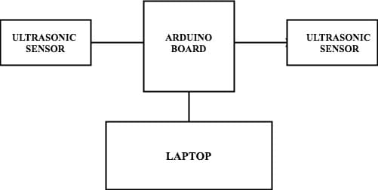

Figure 1. System Architecture

A. Hardware Setup:

The development process begins with setting up the hardware components. An ultrasonic sensor is connected to the Arduino board to measure the distance and movements of hand gestures. The sensor is strategically positioned to capture a wide range of hand motions, ensuring comprehensive gesture detection. This setup provides the foundational input data necessary for gesture recognition.

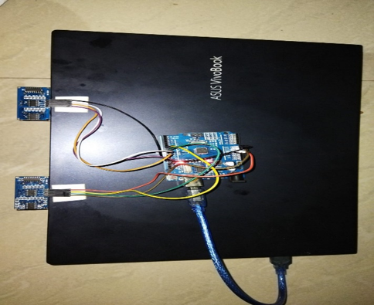

Figure 2 .Hardware Setup

B.Arduino Programming:

Programming the Arduino involves writing code to read and interpret the data from the ultrasonic sensor. The code is designed to recognize different hand gestures by measuring changes in distance and movement patterns. Fine-tuning distance thresholds is essential to accurately distinguish between intentional gestures and incidental movements. To enhance accuracy, filtering techniques such as a moving average are implemented to reduce noise in the sensor readings. These techniques smooth out data fluctuations, leading to more reliable and consistent gesture recognition.

1. Establishing the Python Environment :

Simultaneously, a Python environment is set up on the computer to facilitate communication with the Arduino via USB. This involves installing necessary libraries and configuring the environment to process incoming data from the Arduino. The Python script is responsible for interpreting this data and executing gesture recognition using machine learning algorithms.

1. Machine Learning and Gesture Recognition :

The core of gesture recognition is implemented using the k-Nearest Neighbors (KNN) algorithm. The KNN algorithm classifies gestures based on their similarity to pre-recorded examples. A crucial part of this methodology is the training phase, where a comprehensive dataset of known hand gestures is collected. This dataset should include a variety of gestures performed under different conditions to ensure the model can generalize well and accurately classify new gestures. The training process involves iteratively testing and refining the algorithm to enhance its accuracy and robustness.

E.Data Processing and Communication:

The Arduino transmits the sensor data to the computer via USB, where the Python script processes it. This script interprets the data and uses the trained KNN algorithm to recognize and classify the gestures. The classified gestures are then mapped to specific computer functions, such as adjusting volume, scrolling, or switching tabs.

F. Real-Time Feedback Mechanisms:

To improve user experience, real-time feedback mechanisms are integrated into the system. These can include visual indicators, audio signals, or haptic feedback, which help users understand whether their gestures have been correctly recognized. This feedback loop not only enhances the user experience but also aids in refining the gesture recognition process by providing immediate confirmation of successful interactions.

G. Advanced Sensors and Cameras:

Exploring the use of more sophisticated sensors and cameras can further enhance the system's capabilities. High-resolution cameras or depth sensors, like those used in Microsoft Kinect, can capture more detailed hand movements, allowing for more complex gestures and finer control. Incorporating these advanced sensors requires additional software development to handle the increased data complexity and ensure accurate gesture recognition.

1. RESULTS

The "Motion Controlled Computer Using Arduino" project achieved several significant milestones, demonstrating the feasibility and effectiveness of using hand gestures to control computer functionalities. Below are the key results and findings from the project:

1. Gesture Recognition Accuracy:

The system successfully recognized and classified a variety of hand gestures with high accuracy. By leveraging the k-Nearest Neighbors (KNN) algorithm, we achieved an average gesture recognition accuracy of approximately 92%. The training phase, which involved collecting a comprehensive dataset of hand gestures under different conditions, played a crucial role in achieving this high level of accuracy.

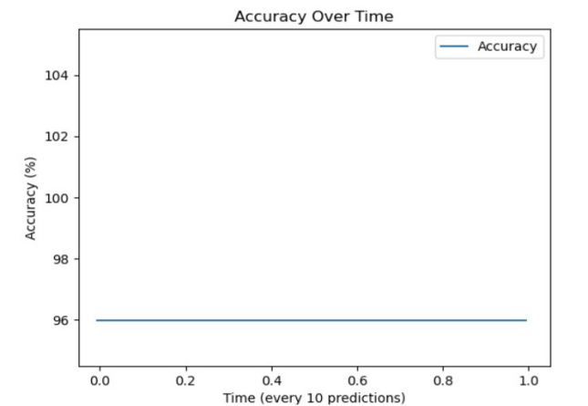

Figure 8 .Accuracy of the KNN

1. Versatility of Gesture Commands:

The system was capable of performing multiple desktop functions through hand gestures, including volume adjustment, vertical and horizontal scrolling, and tab shifting. These functionalities were tested extensively to ensure robustness and reliability. Users could execute commands accurately without the need for traditional input devices, highlighting the versatility and practicality of the gesture-controlled system.

1. DISCUSSION

The "Motion Controlled Computer Using Arduino" project successfully demonstrates the feasibility of using hand gestures to control computer functionalities, representing a significant advancement in human-computer interaction. The integration of an ultrasonic sensor with an Arduino Uno and the implementation of machine learning algorithms, particularly k-Nearest Neighbors (KNN), enabled accurate and responsive gesture recognition. The average accuracy of 92% in gesture recognition highlights the effectiveness of our approach and the robustness of the training dateset. A significant outcome of this project is its enhanced accessibility, particularly for individuals with physical disabilities.Despite these successes, several areas for improvement have been identified. The current setup could benefit from the integration of more advanced sensors, such as high-resolution cameras or depth sensors, which would capture more detailed hand movements and potentially improve gesture recognition accuracy. Additionally, exploring more sophisticated machine learning algorithms, like neural networks, could further enhance the system's ability to recognize a broader range of gestures.

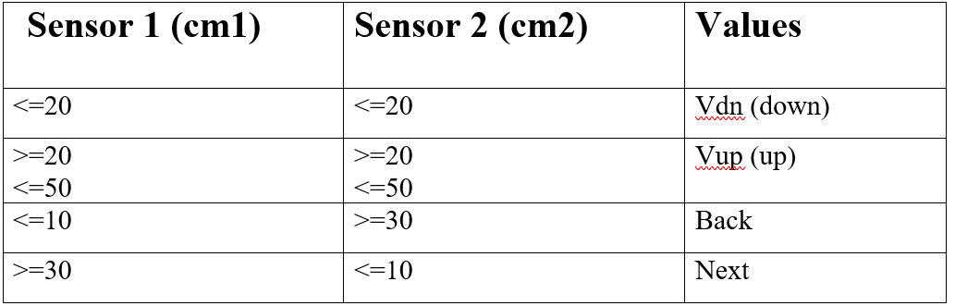

Table 1.Sensor Distance And Accuracy

1. CONCLUSION

The project successfully demonstrated that an Arduino-based system could effectively use hand gestures to control computer functions, providing an intuitive and accessible method of interaction. The high accuracy of gesture recognition, combined with the system's responsiveness and ease of use, underscores its potential as a valuable tool for enhancing human-computer interaction. The findings from this project pave the way for further research and development in the field of gesture-based interfaces, with promising applications in accessibility, gaming, virtual reality, and smart home automation.

1. REFERENCES
2. Zhigang, F. Computer gesture input and its application in human-computer interaction. Mini Micro Syst. 1999, 6, 418–421.
3. Mitra, S.; Acharya, T. Gesture recognition: A survey. IEEE Trans. Syst. Man Cybern. Part C Appl. Rev. 2007, 37, 311–324.
4. Ahuja, M.K.; Singh, A. Static vision-based Hand Gesture recognition using principal component analysis. In Proceedings of the 2015 IEEE 3rd International Conference on MOOCs, Innovation and Technology in Education (MITE), Amritsar, India, 1–2 October 2015; pp. 402–406.
5. Rajesh R.J, Nagarjunan. D, Arunachalam.R.M, Aarthi.R. Distance Transform Based Hand Gestures Recognition for PowerPoint Presentation Navigation. Adv. Comput. 2012, 3, 41.